29|12

JDBC
JDBC- Java Data Base Connectivity
- It’s a java API that allows java programs to interact with databases.
- It provides a standard way to execute SQL statements and retrieve results.
- Driver is used to give information to the JDBC

To use JDBC we need a driver and there are four types of drivers.
- Type 1=> JDBC – ODBC Driver (Open Database Connectivity)
SQL
ODBC
Java
JDBC

This type of Driver uses ODBC API to communicate with database.
It requires ODBC Driver to be installed in the system.
- Type 2=> Native Api Driver
Native API
SQL
Java

This Driver is specific to particular database and provides direct access to the databases native API.
- Type 3=> Network Protocol Driver
SQL
Network
Java

This Driver uses network protocol to communicate with database server.
- Type 4=> Pure/Thin Driver
SQL
Java + Driver

This Driver is completely written in java and does not require any native code or libraires it directly communicates with the database.

Key Components
- Driver Manger: This class is used to register JDBC Driver and get a connection to a database.
- Connection: It represents an open connection to a database. It provides methods for creating statements, managing transactions, etc.
- Statement: It is an Interface used to execute SQL statements. It has methods for executing queries, updates and stored procedures.
- Result Set: It represents the result returned by a query. It provides methods for iterating through the Result Set and retrieving data.
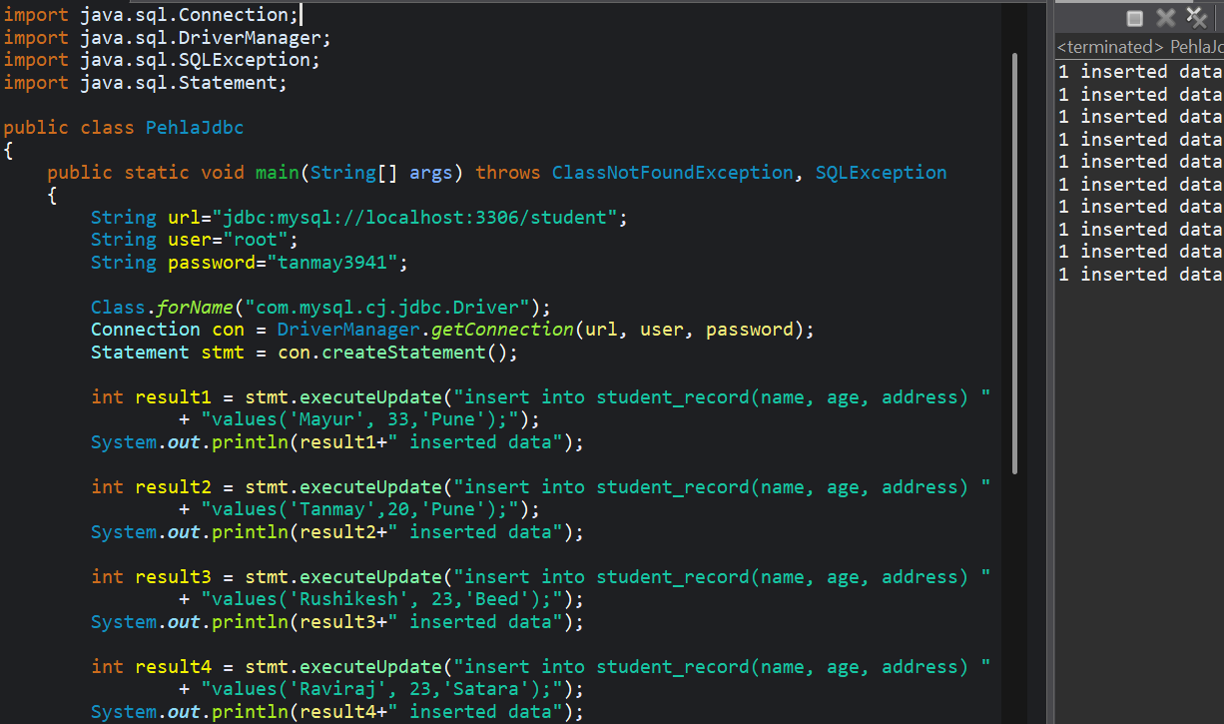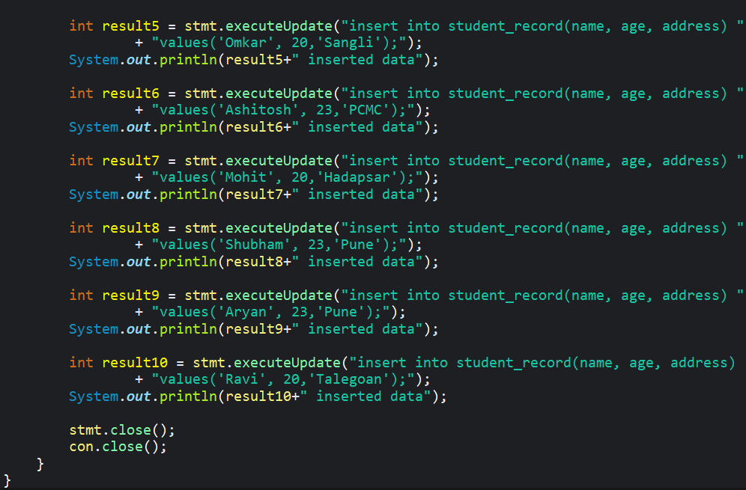
  - Some IMP extra points
- Class.forName(): It is used to load a class dynamically at runtime using class name as a String and is often used in JDBC driver registration.
// Class.forName(“com.mysql.cj.jdbc.Driver”);
- Connection:
  - Connection is an Interface which creates a session between java and database. Without it, java cannot send SQL commands to the database.
// Connection con = DriverManager.getConnection(url, user, password);
  - Connection is required to create: Statement, PreparedStatement, CallableStatement
- DriverManager: We cannot directly use getConnection() because it is a static method of DriverManger. DriverManger is required to load JDBC driver, select the correct driver based on URL, and create a Connection object, keeping our application loosely coupled from the database driver. //Statement stmt= con.createStatement();
- Statement: It is a JDBC interface that takes SQL string, sends it to the database and execute it. createStatement() is a method of Connection, It creates a DB-specific Statement object. //ResultSet rs= stmt.executeQuery("select * from product_data;");
- ResultSet: It is an Interface required to hold the rows returned by the Data Base and provide cursor based access to ream them in java.
executeQuery() is used to execute select queries.
  - IMP Questions
- Why do we use forName()
- Why do we need Connection class in JDBC
- Why do we need DriverManager class
- why do we require Statement and createStatement() why can't we directly write queries in string
- Why do we require ResultSet when we already have Statement?
- We use Statement and executeUpdate() for Update queries.
- In url “jdbc:mysql://localhost:3306/student57” Database name = student57

30|12
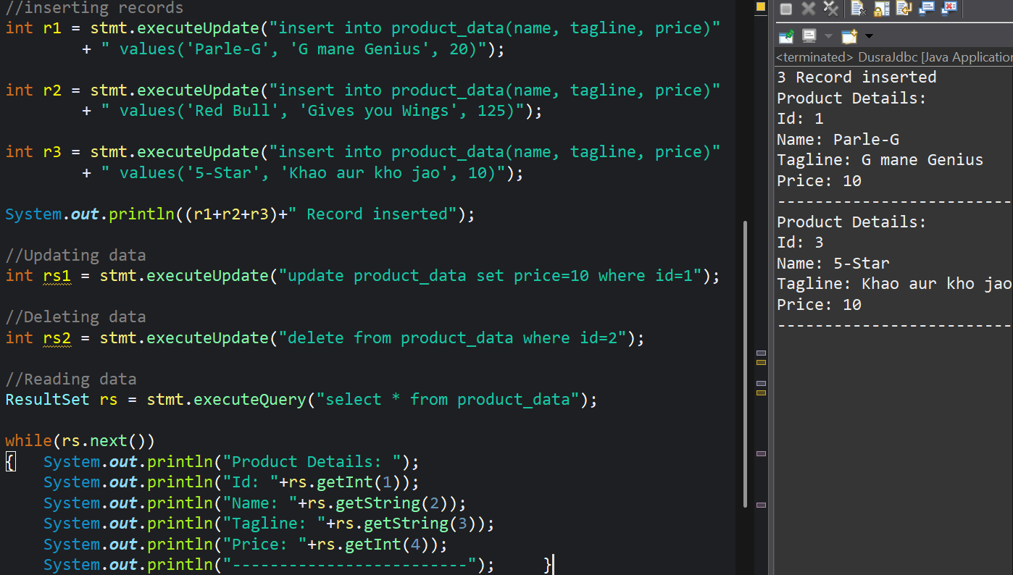

- For select queries we use ResultSet along with statement and executeQuery() in loop.

31|12

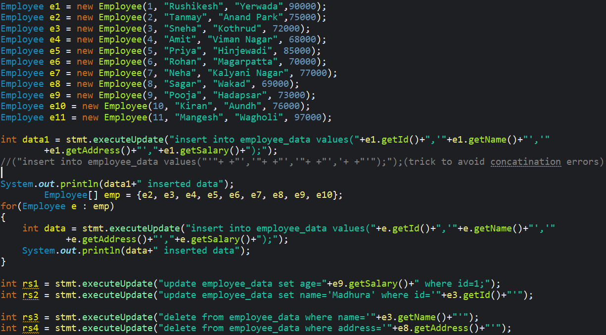

Prepared Statement
- It is an Interface in JDBC used to execute precompile and parameterized SQL queries.
- It uses a place holder ‘?’ and setter methods to provide the values.
- It is the enhancement over the statement Interface.
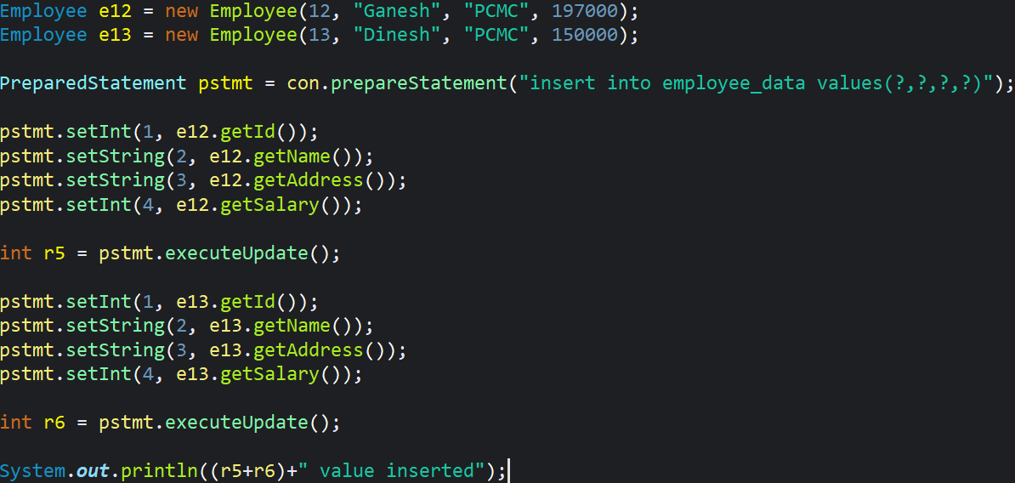
//When we need to filter the data using Prepared Statement
//to read the data using Prepared Statement

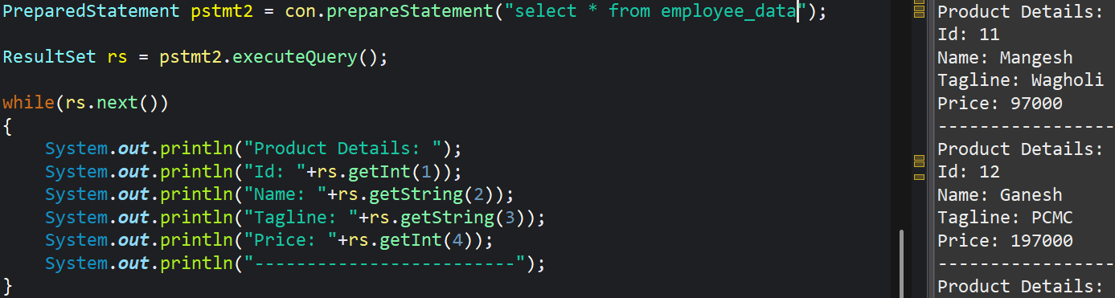

2|1

Transaction Management
Transaction Management is a crucial aspect of Database operations, specially when dealing with multiple updates or queries that need to treated as single unit. If one operation fails, the entire transaction can be rolled back, ensuring data integrity.
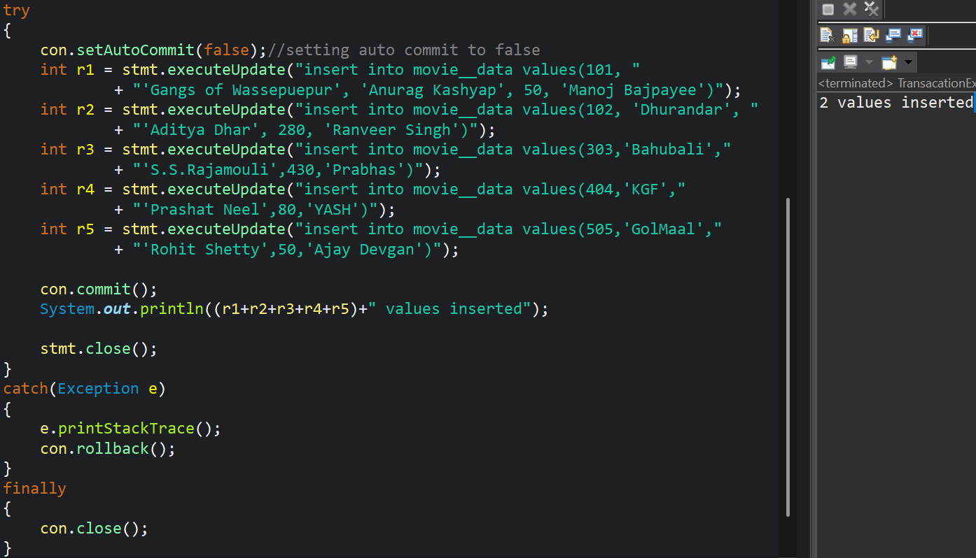

Stored Procedure
stored procedure or procedure is a procedure which is compiled and reused set of sql statement stored In a database
It can take input parameters and return output parameters or resulsets.

Types of parameters
IN parameter: It is the input value passed to the procedure.
Out parameter: It is used to retrieve output values from the procedure.
IN-OUT: Acts as both input and output
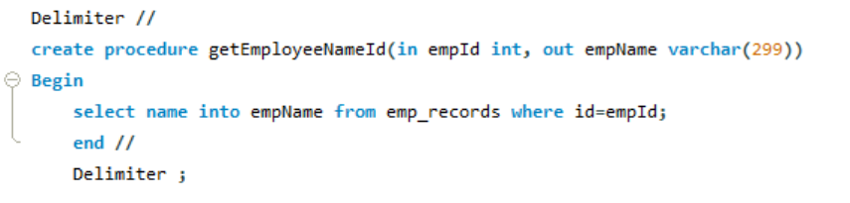
- For single return value
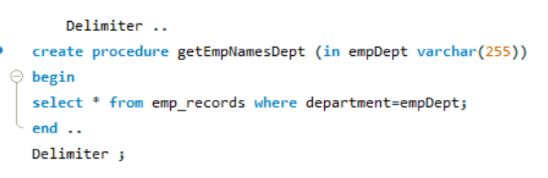
- For Multiple return values

Callable Statement
Callable statements are used to execute stored procedures in the database. They provide a convent and efficient way to interact with database procedures which can encapsulate complex logic and improve performance.
  - Types of Parameters in Callable Statement
- IN parameter: We pass a input value to the procedure in java/JDBC using setter methods.
- OUT parameter: It is used to retrieve values from the procedure in java/JDBC using registerOutParameter() method.
For single return value
- 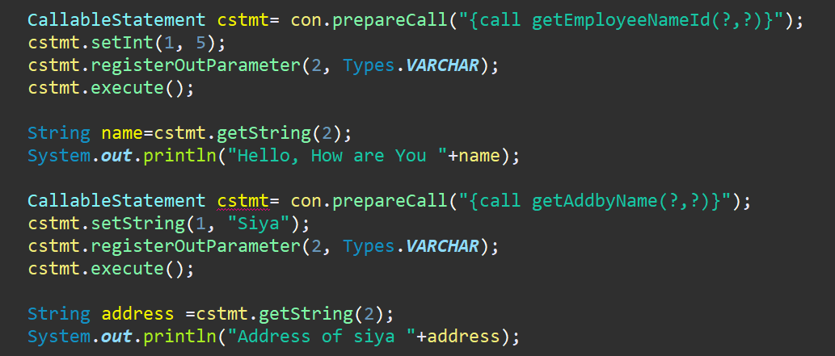
- 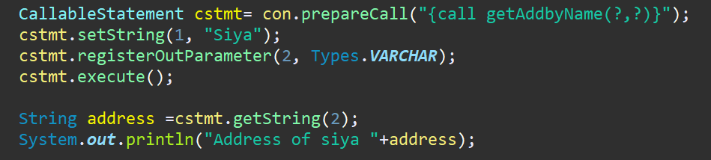
For Multiple return values
- 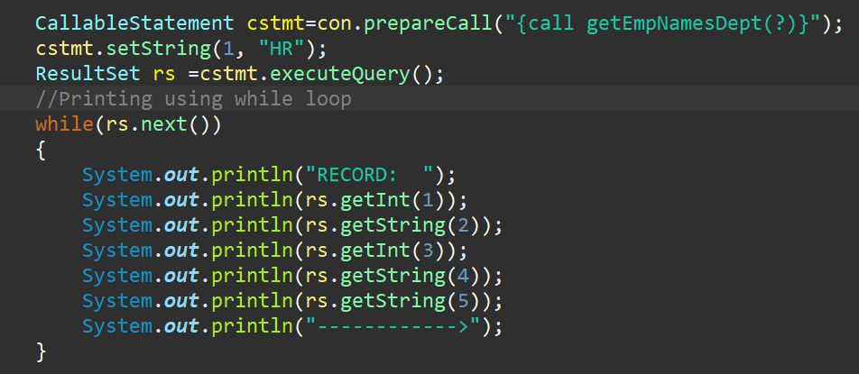

Q. What is difference between ClassNotFoundException and NoClassDefinationE
- ClassNotFoundException- When JVM is not able to find the class at runtime via reflection or dynamic loading
- NoClassDefinationException- When JVM is unable to load a class that was available at compile time but missing at runtime.

Batch Processing in JDBC
It is used to execute multiple sql statements (insert, update, delete) as a batch instead of executing them one by one. This improves performance by reducing the number of database calls and increasing efficiency.
  - Methods used for batch processing are
- addBatch
- executeBatch
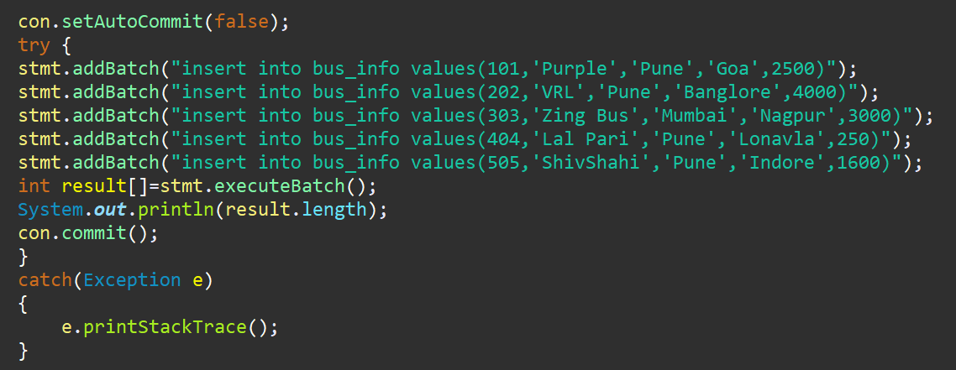

DAO
DAO stands for data access object pattern. It is a design pattern that separates the persistence logic (database operations) from business logic. It provides an abstraction over the data access layer, making system more modular and easier to maintain.
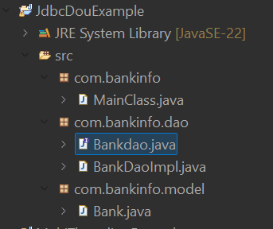
//main package:-com. bankinfo
Contains two sub packages:- com.bankinfo.dao, com.bankinfo.model
Com.bankinfo
- 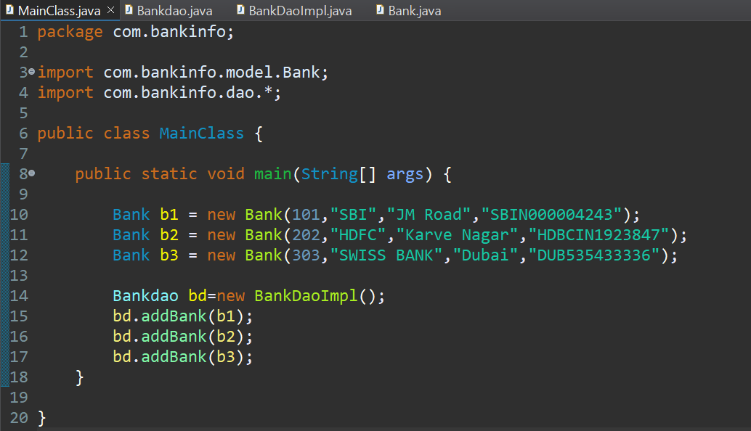

Com.bankinfo.dao
- 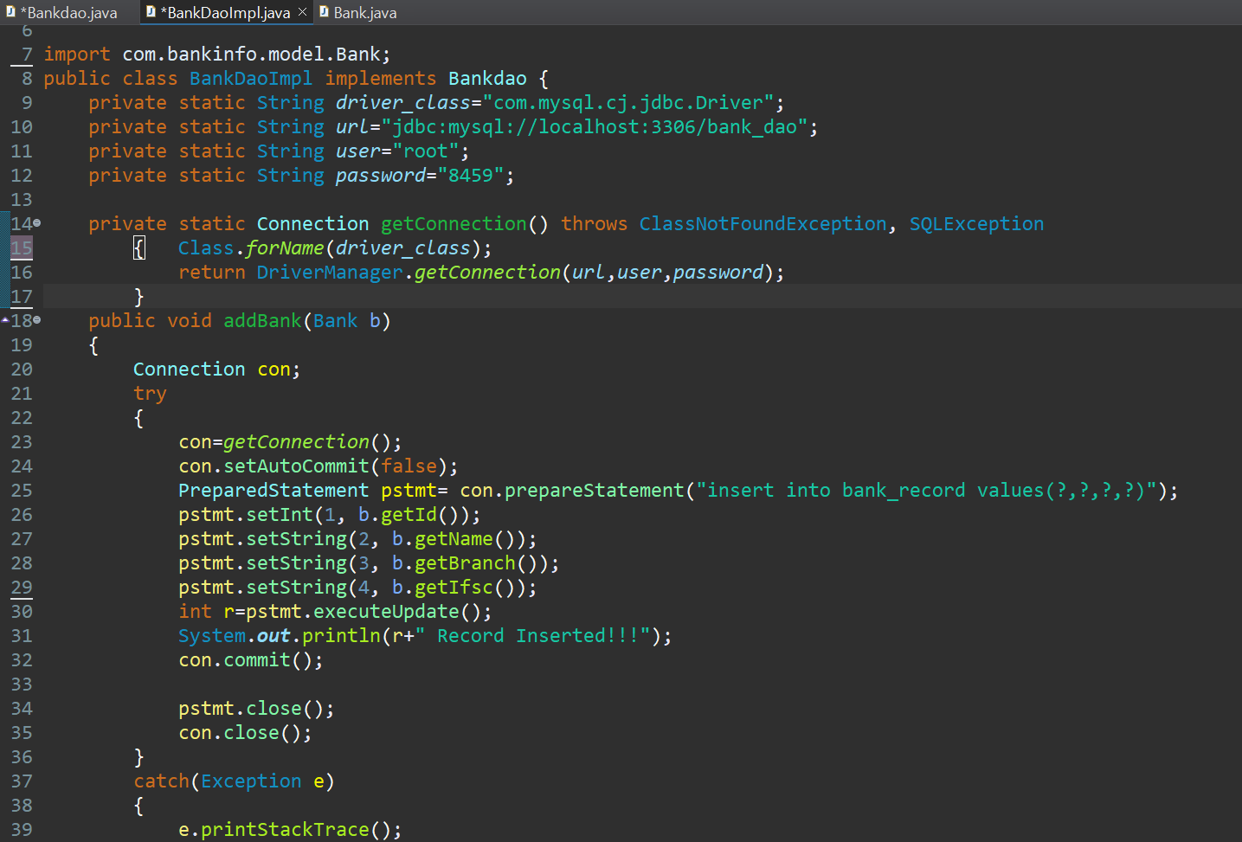
- 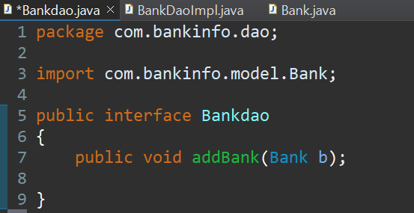
Com.bankinfo.model
- 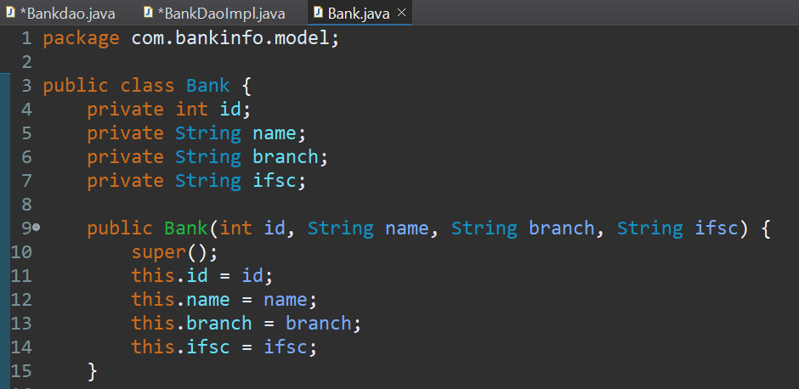
- What is JDBC?
- What is API?
- Why do we need Drivers?

